Atlanta — A City of Hope or Disaster?
By Alysia, Brandon, and Jennifer | April 23, 2026

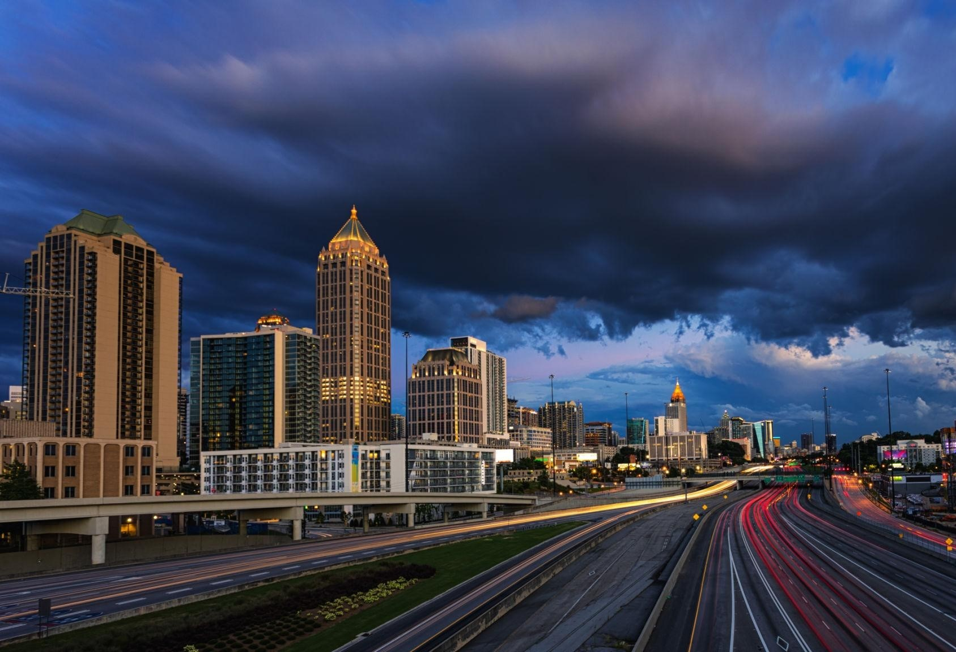
Downtown Atlanta skyline at dusk illustrating the city’s role as a major urban and infrastructural hub.
Atlanta is one of the most recognizable cities in America, but today's Atlanta looks nothing like the city its residents know. Atlanta is not always imagined through its community, culture, or people; it is also imagined through its association with disease, contagion, and emergency response. Through federal public health campaigns and global entertainment, Atlanta has been repeatedly constructed as a symbolic "ground zero," with the media repeatedly returning to it as the place where crisis is centered and managed. This is a shift in who produces media and whose perspectives get centered, and it has fundamentally changed how the city is imagined on a national and global scale. Contemporary media including The Walking Dead, CDC’s Zombie Preparedness 101 graphical novel, and Stranger Things contribute to the multidimensionality of Atlanta as the frontline of crises.
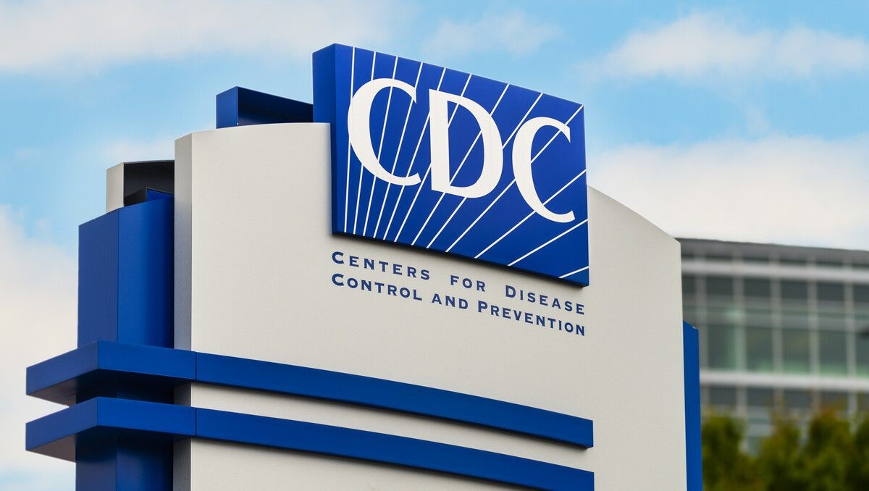
Signage at the Center for Disease Control and Prevention headquarters in Atlanta, GA.

“The CDC isn’t just from Atlanta, it is Atlanta.”
Contemporary media has cast Atlanta as the global center of scientific authority. The city's identity is almost entirely tied to one institution: the Centers for Disease Control and Prevention. The CDC doesn't just operate out of Atlanta; in the media, it is Atlanta. The stories told through and about the CDC position the city as a high-tech, indispensable control room for human survival. Atlanta's primary value, in this framing, is entirely functional, as its existence is not only a place where people live but also a hub that serves everyone.
Across both institutional messaging and entertainment media, the city is framed as a healthcare hub in which information is produced, crises are managed, and solutions are developed. Two of the clearest examples of these are the CDC Zombie Preparedness 101 campaign and The Walking Dead.
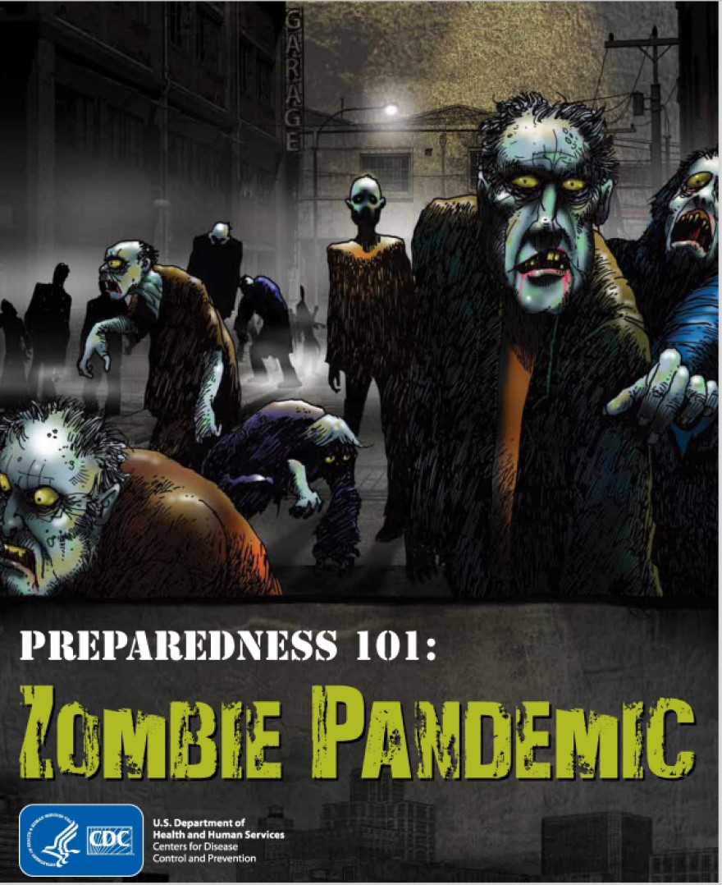
The CDC campaign targets the general population to increase awareness of emergencies.
The creation of the CDC campaign is not just a government agency giving tips, but a medium through which Atlanta’s identity is constructed to the public. The use of zombies in a comic-book medium, centered on the trope of heroes and villains, reinforces the idea that the CDC is closely tied to disease response and public authority, and serves as this “savior” of the
South. By presenting a fictional outbreak using imagery often associated with emergencies, the campaign directly targets the general population through a peripheral route of persuasion. While the goal was to convince the public to create a plan for general emergencies, it unintentionally reinforced the idea that Atlanta is not just a city but a central hub for crisis management. Media is not just informing people – it’s actively constructing how we think about place, risk, and authority.
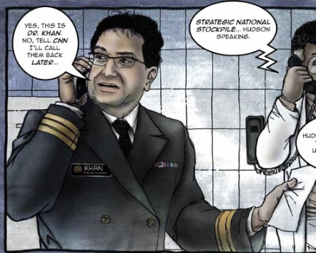
Panel from CDC Zombie Preparedness 101

When we look at the specific frame in which Dr. Khan tells CNN he’ll “call them back,” it positions Atlanta as the ultimate information capital. It frames the city as a gatekeeper of global information. In this narrative, Atlanta is the epicenter of truth—a place where the world’s largest news organizations have to wait upon the CDC for the latest information. It suggests that the city doesn’t just house a lab; it houses the authority that gatekeeps global truth.
This media-making constructs an identity for Atlanta that is defined by absolute institutional competence. It tells the public that Atlanta isn't just a historic city; it is a high-tech, indispensable 'Healthcare Hub' that functions as the global control room for human survival. When we put The Walking Dead alongside the CDC campaign, a clear pattern emerges. Both center on the same ideas: rapidly spreading disease, systems breaking down, crisis response, and Atlanta serving as the center. In both cases, Atlanta's actual cultural identity gets replaced by this singular image of crisis.
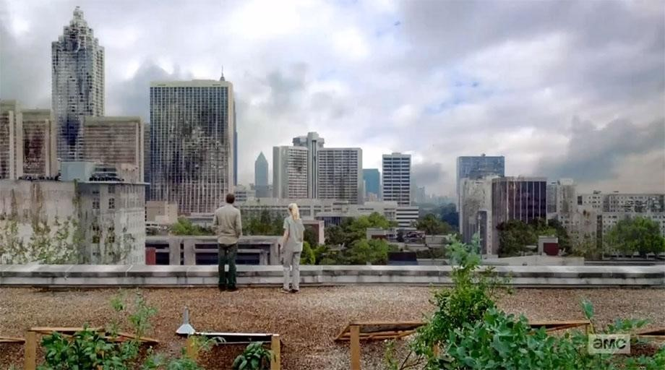
Scene from The Walking Dead depicting survivors overlooking a deserted Atlanta skyline
In The Walking Dead, it opens with the city completely abandoned after a viral outbreak. Atlanta is portrayed as the starting point of that collapse, and its real cultural identity is largely absent as it becomes a generic backdrop for an apocalypse. The CDC no longer seems like a center for information or safety. Atlanta is shown here as a false beacon of hope. The protagonist is going to Atlanta to the CDC for a promise of safety, but this city, looking abandoned, evokes a sense of hopelessness. The media is arguing that the city's institutional reputation was a lure to a dead end.
As the symbolic “ground zero” for crises, many contemporary media have chosen Atlanta as the origin of the crisis. Other than The Walking Dead, the popular series Stranger Things was also shot at Atlanta. The Walking Dead is considered a classic in the post-apocalypse genre, and Stranger Things is a blockbuster series gaining wide popularity in the younger generation. Both of these shows have global influence, and fans have been attracted to Atlanta, which benefits the local economy. At the same time, the Atlanta portrayed by these shows influences the way the city is imagined.
The CDC’s geological placement builds Atlanta’s identity as the authoritative crisisresolving center, with abilities to help local communities, the country, and even the world to overcome challenges. However, scientific institutions are still shaped by politics, funding, and leadership. Recent funding cuts and leadership vacuum of the CDC are both results of political influence. The image CDC and other active biotech companies in Atlanta have built is one that only accounts for the bright side of the story. TV shows create fictional worlds, but those worlds often reflect real fears and disputes from society. Both The Walking Dead and Stranger Things share the same pattern of elite science institutions gone wrong, and ordinary people are left to deal with the disastrous consequences.
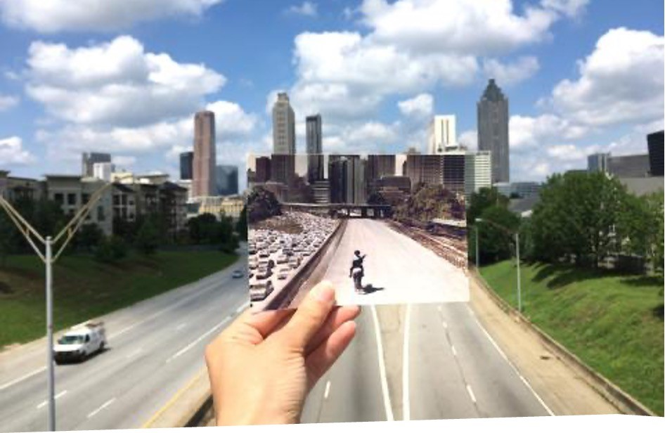
Scene from The Walking Dead from the Jackson Street Bridge in Atlanta. Photo by Andrea David.
The Walking Dead features a French biotech corporation leaking the zombie virus, and Stranger Things features a government-involved laboratory performing experiments on children for their psychological superpowers. The directors of Stranger Things wanted to title the show “Montauk” or “Long Island” originally, which are conspiracies that alleged governmentinvolved research for developing psychological warfare techniques.
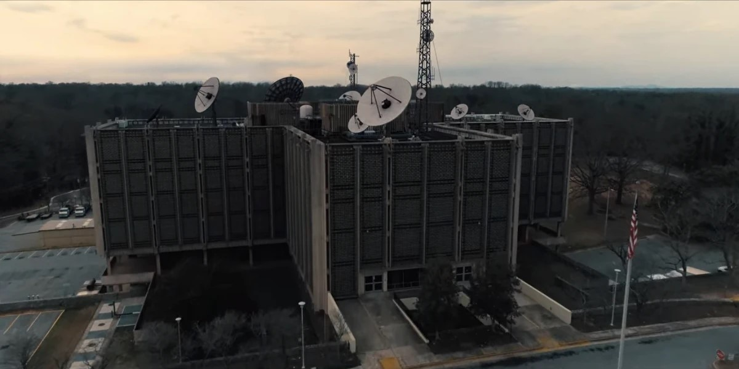
“Hawkins Lab” in The Stranger Things, located in Emory University’s Briarcliff campus, originally used as a mental health treatment facility.
The similar story built on unethical experiments conducted by science institutions conveyed in these shows add a dark side to Atlanta. The two fictional shows caution the audience of the consequences of scientific institutions in the hands of the wrong people, exacerbating people’s distrust and skepticism toward these institutions, such as the CDC. The tragic case of a police officer shot by an anti-vaccine protester at the CDC reflects the detrimental outcome of the wobbling trust in these scientific institutions.
Atlanta as the home to CDC, a leading public health institution that is helping to combat crises, along with many other biotech and pharmaceutical companies, has been framed as a center of scientific advancement and center for disease prevention and control. The three contemporary media examined were all based in Atlanta, and highlighting the city as the symbolic “ground zero”, where crises begin and take place. The fictional stories told by these media contribute in different angles to Atlanta’s identity around science-related crises and crisis response, complicating Atlanta both as a city of hope and disaster.

